*1)Fibonacci Series using recursion.*

*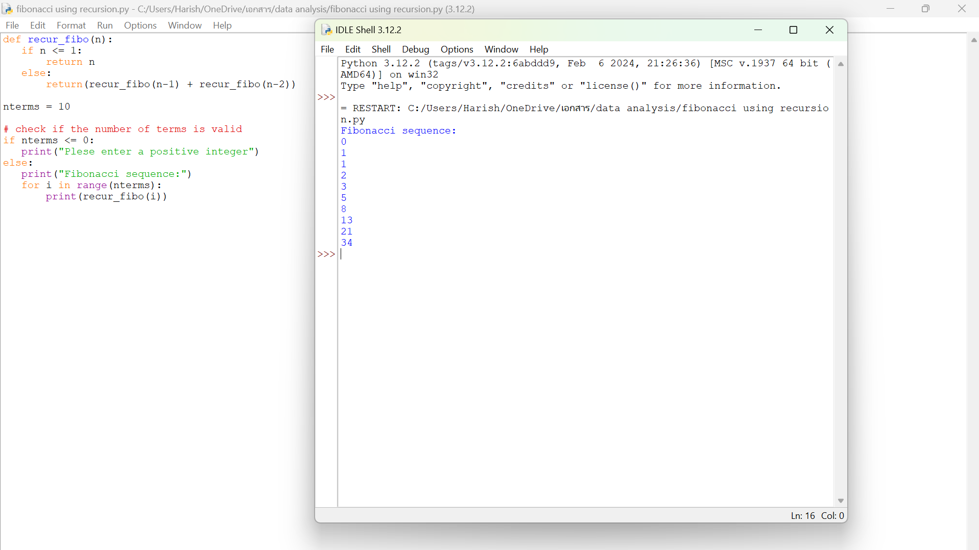*

*2) check the given no is Armstrong or not using recursive function.*

*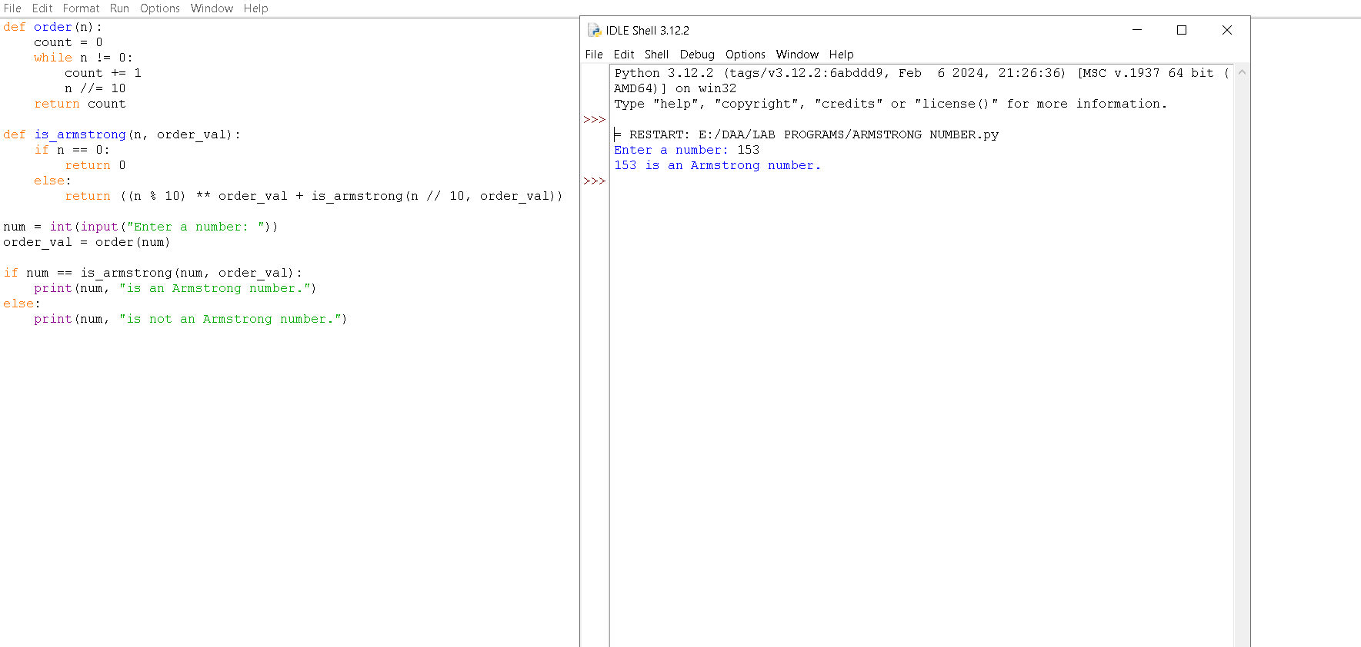*

*3) GCD of two numbers using recursive factorization*

*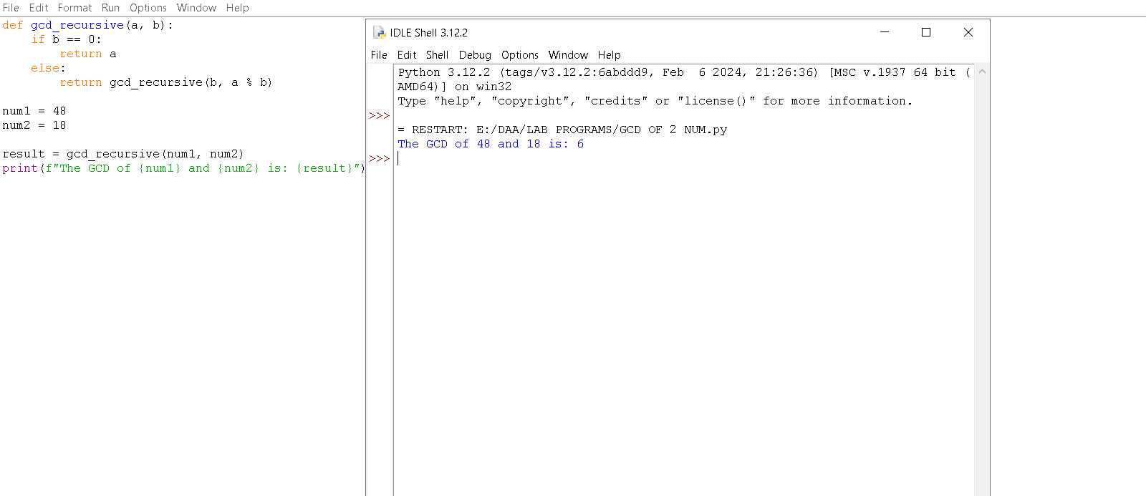*

*4) the largest element of an array.*

*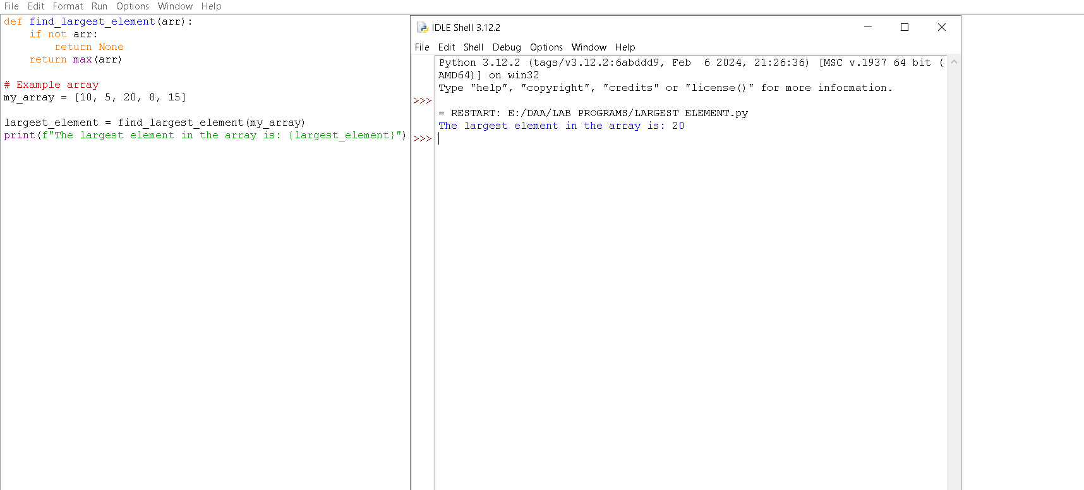*

*5) the Factorial of a number using recursion.*

*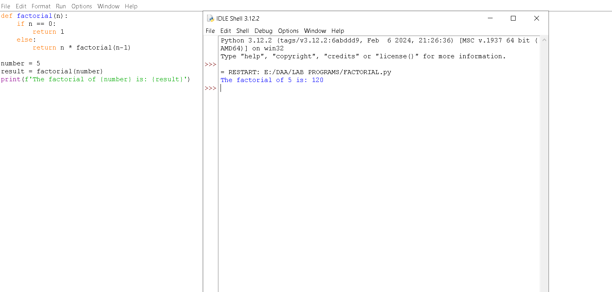*

*6) copy one string to another using recursion*

*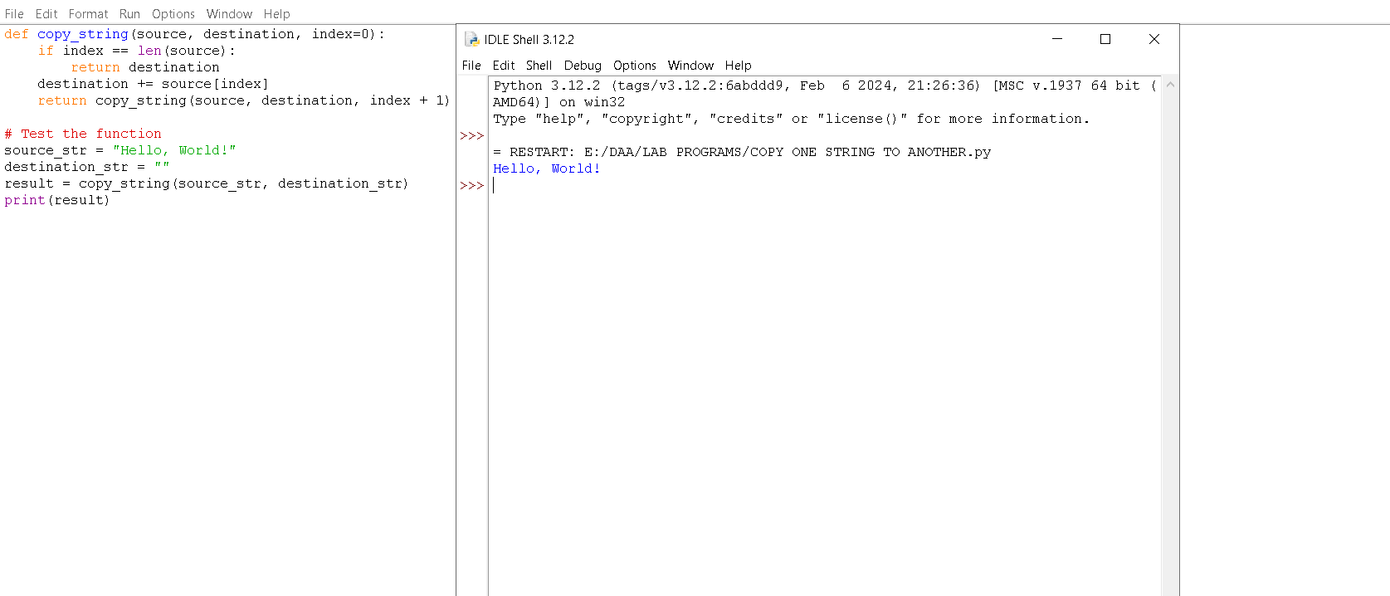*

*7) the reverse of a string using recursion*

*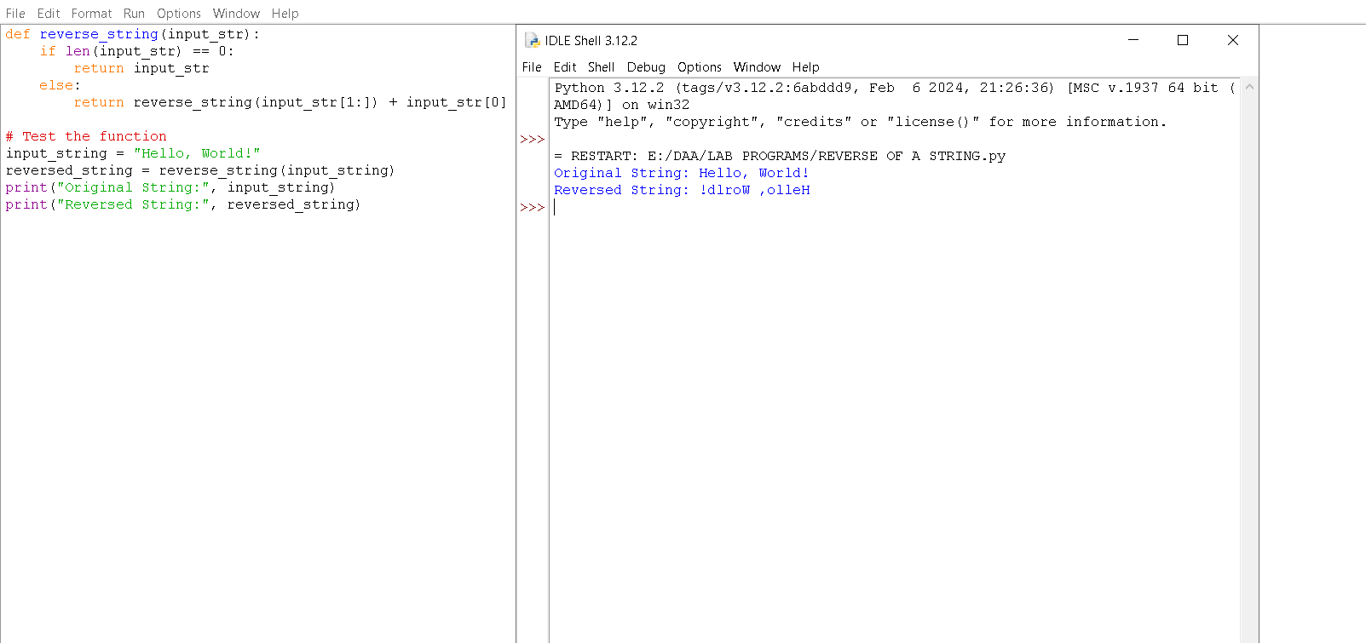*

*8) generate all the prime numbers using recursion*

*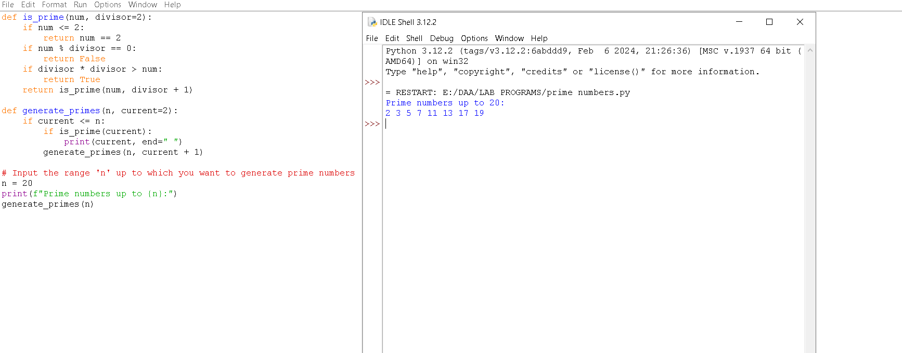*

*9) to check prime number or not using recursion*

*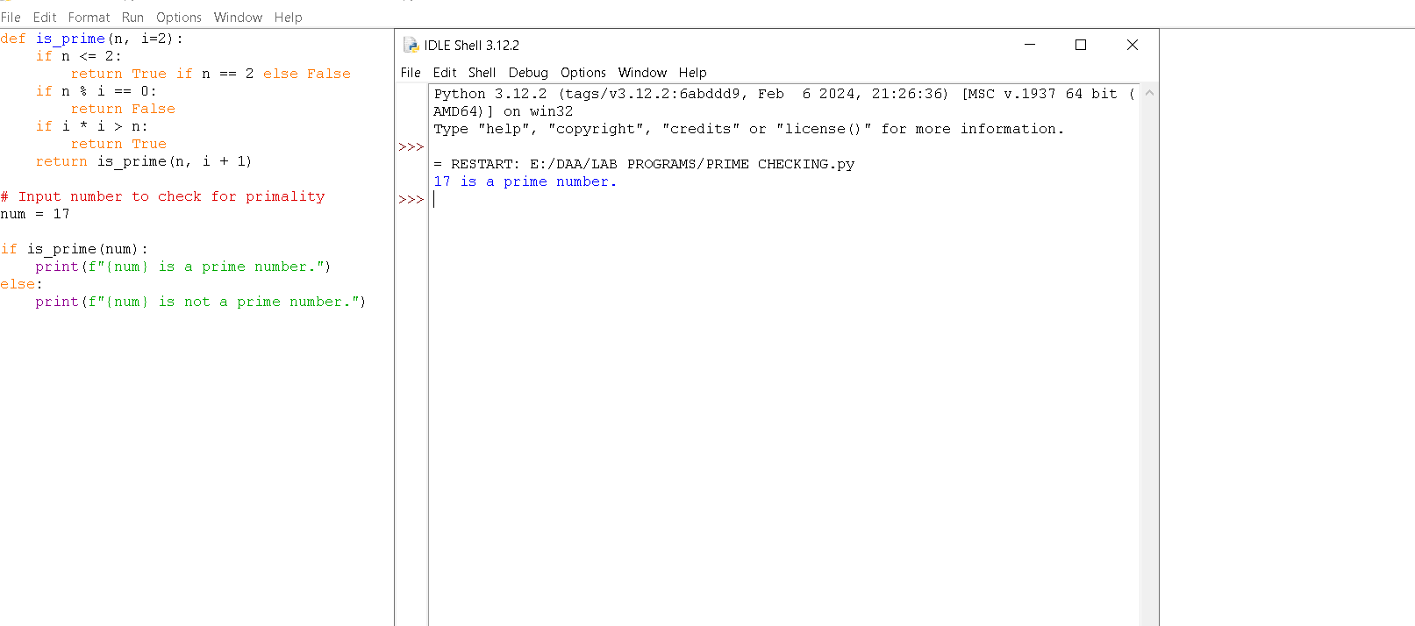*

*10) to check Palindrome or not using recursions*

*